|  |
| --- |
| EPF |
| Planning Taylor |
| Project evolution management |

|  |
| --- |
| DUMAS DE LA ROQUE Marion – FRANCIS Rémy – GIMOND Théo – GOUTARD Léo – SAMMUT Justine  22/03/2024 |

Table des matières

Table des matières 1

Project background 3

The sponsor 3

Stakeholders 3

Dependencies 4

The team 4

Product/service 5

Vision 5

Why do we want this product or service? 5

Benefits and Expected Changes: 5

Actors and stakes 5

Who will be impacted by this project? 5

Current Problems of These Actors: 5

A Better Situation for Them: 6

Expected Impacts of the Project: 6

Activities Impacted: 6

Usage Scenarios at the End of the Project: 6

Risks 6

Mary Stephenson (Language Section Responsible): 6

Teachers: 7

Administrative Staff: 7

Roadmap 7

Mid-project objective: 8

Where to start: Minimum Viable Product (MVP) 8

Product Backlog 8

User Story Map 8

Trello using Presentation. 9

Annexes 10

Success Criteria: 10

Taking Risks into account 10

Scenario: Data Import 10

Risks 10

Solutions kept. 11

Road Map 11

# Project background

## The sponsor

In this case, we are examining a project initiated to enhance the efficiency of language section planning, specifically designed for Mary Stephenson, the responsible party for the language section. This initiative roots from the critical need to address the significant time and effort expended in the creation and updating of LV1/LV2 planning, which Mary found unsatisfactory due to its reliance on manual processes such as the use of post-it notes or Excel spreadsheets. These methods, while traditional, are prone to errors, time-consuming, and lack the flexibility required for efficient schedule management.

The sponsor of this project is the organization overseeing the language section, which has identified the inefficiencies and sought a technological solution to streamline the process. This organization, while not detailed in figures, is presumably an educational institution or a language training provider that values innovation and efficiency in its operations. The key elements of this organization likely include a commitment to language education, a structured curriculum that necessitates careful planning of language levels (LV1/LV2), and a dynamic schedule that requires frequent updates.

The genesis of the project came directly from the identified need by Mary Stephenson to improve the planning process within the language section she oversees. The manual methods currently in use were deemed inadequate, leading to the search for a solution that could save time and reduce the margin for error.

The sponsors, in this context, are the decision-makers within the organization who have recognized the potential benefits of implementing a new system. They have the authority to approve the project, allocate resources, and ensure its alignment with the organization’s objectives. These individuals or bodies are invested in the project because it directly impacts the efficiency and effectiveness of the language section's operations. By automating the planning process through a Python program linked to a graphical interface on a web page, the project promises to significantly reduce the time and effort involved in creating and updating the language courses' schedules.

For the sponsors, the stakes include the potential to enhance the overall quality of the language education provided, to increase the satisfaction of the staff responsible for planning, and to set a precedent for leveraging technology to solve operational challenges within the organization. By addressing these inefficiencies, the organization not only improves its internal processes but also potentially enhances its reputation as a forward-thinking and efficient educational provider.

## Stakeholders

In the context of the project aimed at enhancing the planning process for language sections through a Python program and web interface, several stakeholders beyond the project team are deeply involved and affected by its outcomes. These stakeholders include:

* Mrs. Stephenson (Client): As the language section responsible and the individual who identified the inefficiency in the current planning process, Mrs. Stephenson is the primary client and a key stakeholder. She is directly concerned with the project's success because it addresses her specific needs – saving time and reducing the complexity of creating and updating the LV1/LV2 planning. The stake for her is significant as the project's outcome directly impacts her daily operational efficiency and job satisfaction.
* Mrs. Zitzmann & Mr. Grosjean (Technical Managers): These individuals are responsible for the technical aspects of the project. They play a crucial role in ensuring the technical feasibility, overseeing the development of the Python program, and ensuring the web interface meets the project's requirements. For Mrs. Zitzmann and Mr. Grosjean, the project is an opportunity to showcase their technical expertise and contribute to operational improvements within the organization. The stakes include the successful delivery of a robust and user-friendly solution, professional recognition, and potentially setting a technological standard for future projects within the organization.
* EPF: Represented by Mrs. Zitzmann and Mrs. Stephenson for project compliance, in particular regarding data privacy, software licenses and compliance with educational regulations. The challenge for this stakeholder is to ensure that the project complies with all relevant laws and regulations, thus protecting the organization from possible legal challenges.

Each of these stakeholders has a vested interest in the project's outcome, albeit from different perspectives. Their concerns range from operational efficiency and technical success to legal compliance and professional recognition. The success of the project hinges not only on its technical merits but also on its ability to meet these diverse stakeholder needs and expectations.

## Dependencies

There are no teams directly involved but there is a dependency on the input from Moodle tests, this highlights a critical technical dependency that could affect the durability of the project, scope, and success. The Moodle learning platform is widely used in educational settings for creating online courses and managing assessments. The dependency indicates that the algorithm developed for the project must be compatible with data exported from Moodle to fetch test results or other relevant data. This requires careful coordination and possibly negotiation with the administrators of the Moodle system, ensuring access to necessary data, and may also involve technical challenges related to data format, privacy, and security considerations. The success of the project, therefore, hinges not just on internal efforts but also on effectively managing this external dependency.

## The team

The team tasked with developing and implementing the Python program and web-based interface for the language section planning consists of five members, all of whom are part of the MDE class. These individuals bring a diverse range of skills, interests, and personal objectives to the project, contributing to a rich collaborative environment.

DUMAS DE LA ROQUE Marion – FRANCIS Rémy – GIMOND Théo – GOUTARD Léo – SAMMUT Justine

Overall, the diversity in objectives and skills among team members suggests a comprehensive approach to the project.

# Product/service

## Vision

### Why do we want this product or service?

The primary motivation behind developing this product is to address the inefficiency and time-consuming nature of the current methods used for creating LV1/LV2 planning, which typically involve manual processes using post-its or Excel spreadsheets. These traditional methods are prone to errors, difficult to update, and inefficient for managing the distribution of students and teachers into level groups, as well as for assigning classrooms and time slots.

### Benefits and Expected Changes:

The project aims to bring about significant improvements in how educational institutions plan and manage their LV1/LV2 schedules by:

* Automating the creation of planning schedules: Reducing the manual effort required, thus saving time and minimizing human error.
* Facilitating updates: Making it easier to adjust plans as needed, for example, when new students enroll or teachers’ availability changes.
* Optimizing student and teacher distribution: Using algorithms to efficiently allocate students and teachers to appropriate level groups.
* Enhancing information sharing and visualization: Providing a visual support system for sharing and publishing group allocations, classroom assignments, and schedules.

These changes are expected to lead to a more efficient, flexible, and user-friendly approach to managing educational planning, ultimately benefiting administrators, teachers, and students by improving the overall educational experience.

## Actors and stakes

### Who will be impacted by this project?

Language Section Responsible (Persona: Mary Stephenson): Mary represents the administrative staff responsible for organizing and managing language course schedules, teacher assignments, and student group distributions. The primary problem Mary faces is the significant amount of time and effort required to manually create and update LV1/LV2 planning using traditional methods like post-its or Excel spreadsheets.

### Current Problems of These Actors:

Wastes a significant amount of time manually creating and updating the LV1/LV2 planning, leading to inefficiencies and potential for errors.

### A Better Situation for Them:

A streamlined, automated system for creating and updating the planning would drastically reduce the time and effort required, allowing for more strategic tasks to be prioritized.

## Expected Impacts of the Project:

### Activities Impacted:

* Planning creation and updates for language courses.
* Teacher and student group assignments.
* Communication of schedules and room assignments.

### Usage Scenarios at the End of the Project:

With a few clicks, Mary can generate or update the entire language section's planning, quickly resolving conflicts and making adjustments as needed.

## Risks

### Mary Stephenson (Language Section Responsible):

#### Usage Scenarios:

Mary needs to generate or update the language course planning quickly and efficiently using the automated system.

* Mary downloads the student list from Moodle in csv format.
* Mary put the file in the application and adjusts the settings.
* Mary launches the planning generator.
* Mary can visualize and manipulate the groups & planning.
* Mary can share the data with their colleagues.

#### Identified Risks and Mitigation Actions:

* **Risk**: Inadequate training or user interface complexity could hinder Mary's ability to effectively use the planning tool.
* **Mitigation Action**: Provide comprehensive training sessions for Mary, focusing on both the functionality and usability of the system. Continuously gather feedback to identify areas of improvement in the user interface and streamline processes.
* **Risk**: System downtime or technical issues could prevent Mary from accessing the planning tool when needed.
* **Mitigation Action**: Implement redundant servers or cloud-based solutions to ensure high availability and minimize the risk of downtime. Regularly perform system maintenance and updates during off-peak hours to minimize disruption.

### Teachers:

#### Usage Scenarios:

Teachers rely on the system to receive notifications of their assignments and changes to their schedules.

#### Identified Risks and Mitigation Actions:

* Risk: Notifications may not be delivered promptly or accurately, leading to confusion or missed updates.
* Mitigation Action: Implement robust notification systems with multiple channels (e.g., email) to ensure messages reach teachers in a timely manner. Regularly test notification delivery to identify and address any issues.
* Risk: Teachers may encounter difficulties understanding their assignments in the planning.
* Mitigation Action: Provide a dedicated documentation support to answer any questions or concerns.

### Administrative Staff:

#### Usage Scenarios:

Administrative staff use the system to support logistical tasks such as room assignments and time slots.

#### Identified Risks and Mitigation Actions:

* Risk: Inefficient or error-prone processes within the system could result in incorrect room assignments or scheduling conflicts.
* Mitigation Action: ???
* Risk: Lack of integration with other systems or tools used by administrative staff could lead to duplication of effort or data inconsistencies.
* Mitigation Action: Integrate the planning system with existing tools and databases used by administrative staff to streamline data exchange and ensure consistency across platforms.

## Roadmap

### Mid-project objective:

* Have an algorithm to create groups and a schedule without taking into account conflicts.
* System operates locally.
* Have a first wireframe accepted and validated by the client.

## Where to start: Minimum Viable Product (MVP)

?????????

## Product Backlog

### User Story Map

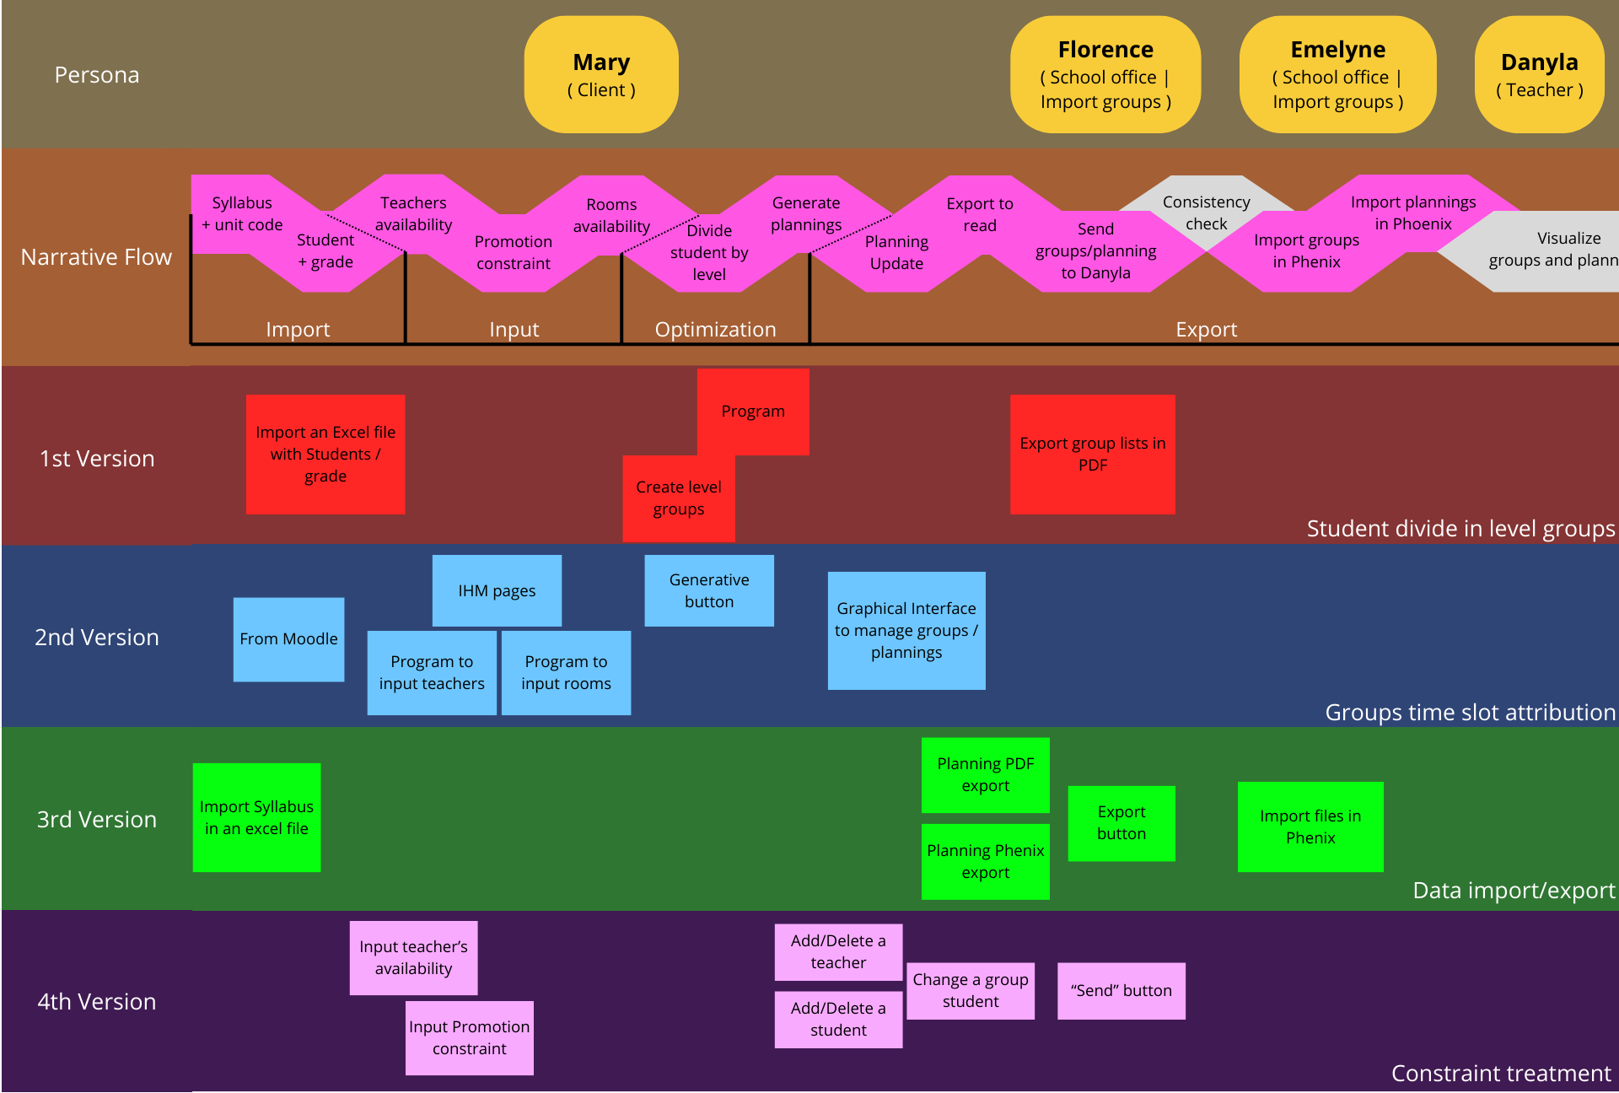

## Product Backlog

# Project management

## Iterative and incremental cycle

### Iterative and incremental cycle

Due to the format of the project and the need for ongoing collaboration with clients and stakeholders, each cycle between meetings is set at a duration of two weeks, ensuring regular updates, feedback, and progress tracking. Even if some meetings have been moved.

### Planning

The objectives of each iteration, the scope (requirements), and the technical work to be done during an iteration are determined collaboratively by the project team. This determination process typically involves the following elements, Product Backlog and User Story Map. This approach ensures that the project remains focused on delivering the most valuable features and that the technical work aligns with the overall goals of the project.

### Team synchronization

Overall, the team communicates regularly during an informal exchange on the subject. As well to share his progress or his problems as to motivate. However, more formal meetings are held at the same frequency as the review meeting.

### Continuous improvement

## Roles

## Communication

### Within the Team:

1. Messenger:

This platforms allow for quick exchanges, informal discussions, and sharing of updates or queries used for real-time communication within the team.

2. Trello:

Project management tools like Trello are utilized for organizing tasks, tracking progress, and collaborating on specific projects or workflows. Trello boards provide a visual representation of tasks, deadlines, and statuses, facilitating transparency and alignment within the team.

### Between the Team and Stakeholders:

1. Email:

Email serves as a formal means of communication between the team and stakeholders for sharing important updates, documents, meeting invitations, and project-related correspondence. It allows for asynchronous communication and documentation of discussions.

2. Meetings:

Face-to-face meetings or virtual meetings via video conferencing tools (Teams) are conducted periodically to discuss project progress, gather feedback, address concerns, and align on priorities with stakeholders. These meetings provide an opportunity for direct interaction and collaboration between the team and stakeholders.

### Solution for Sharing Project Documents and Collaborating on Documents:

1. GitHub:

GitHub is a widely used platform for version control, collaboration, and sharing of code and project documents among development teams. It provides features such as repositories, branches, pull requests, and issue tracking, facilitating efficient collaboration, code review, and documentation management.

2. Trello:

Trello also serves as a solution for sharing project documents and collaborating on documents within the team. While primarily a project management tool, Trello allows for attachments and comments on cards, enabling team members to share relevant documents, brainstorm ideas, and discuss project-related topics directly within the Trello board.

3. Microsoft Applications:

Microsoft applications like SharePoint and OneDrive are utilized for document management, file sharing, and collaboration within the team. These platforms offer features such as document libraries, version history, real-time co-authoring, and access controls, supporting seamless collaboration on project documents and ensuring centralized storage and accessibility.

# Engineering

## Quality management

By formalizing decisions and implementations in project documentation and ensuring that code and documents are well-documented, the project team can effectively manage code and document configuration throughout the project lifecycle and facilitate seamless collaboration, maintenance, and knowledge transfer. This is done by making a maintenance guide.

## Technical architecture elements

### Design approach

### General design

The product design is carried out in collaboration with the customer in order to define the technical functionalities sought early.

### Infrastructure

# Annexes

For: Mary Stephenson – Language section responsible.

Not satisfied by: Waste of time to create the LV1/LV2 Planning.

Our product is: a python program linked to a graphic interface on a web page.

That bring: a time saved by:

- Automation of the planning creation   
- Facilitate updates.

Unlike in: manually with post-its or excel.

Allows to:  
- Share out students in level groups with an optimized way.   
- Share out teachers in level groups.  
- Share/publish information with a visual support.   
- Affect a room/time slot to a group.

## Success Criteria:

* Visualize the groups in 1 click.
* Export data to a format compatible with Phenix.
* Mary finishes the planning creation in 1 day without conflict.
* List of non-resolved conflict
* Groups effectives chosen by the User.

# Taking Risks into account

### Scenario: Data Import

* Mary downloads the student list from Moodle in csv format.
* Mary put the file in the application.
* Mary launches the planning generator.
* Mary can visualize and manipulate the groups.

### Risks

|  |  |  |
| --- | --- | --- |
| Rendering | Language | Conflicts management |
| IT support | Which language to use? | Evaluate:   * Preselection (team review) * Prototype |
| PDF from prototype | Document oneself | Think about many solutions |
| Modeling | Try |  |
|  | Ask to ChatGPT (advantage | inconvenient) |  |

### Solutions kept.

# Road Map

